When do I need to submit an absence change request in Talent Ed?
How you make a change to your time off transaction depends on the status. The status can be found by viewing your time off transactions in Skyward Employee Access under Request Time Off. If you do not see your status you can insert the status column. It should look something like this …

Three status types:
- A time off transaction with a “waiting approval” status means your Admin has not approved or denied your transaction.
- This leave has not been deducted from your leave balance.
- If you need to cancel a time off transaction that is awaiting approval, you can still delete this in Skyward Time Off in Employee Access. You will use the icon to “Request Time Off” then click the down arrow next to the transaction you need to remove, select “delete”.
- You will not be able to edit a transaction waiting approval. However, you can delete and then re-enter with the appropriate information. An absence change request would not be required.
- A time off transaction with a “denied” status means your Admin did not approve this transaction.
- This leave day will not be deducted from your leave balance.
- If this transaction was in error, you do not need to delete or enter an absence change request. You will just create a new time off transaction.

- A time off transaction with an “approved” status means your Admin has approved this transaction.
- This leave day has been deducted from your leave balance.
- If you need to make a change to an approved transaction you will need to submit an absence change request via Talent Ed.

How to submit an Absence Change Request in Talent Ed

You can access Talent Ed through the Staff Portal …

To complete Absence Change Request
FOR EMPLOYEE ACCESS

Click on the icon for “Blank Docs” in the upper right hand corner and select “absence change request”.

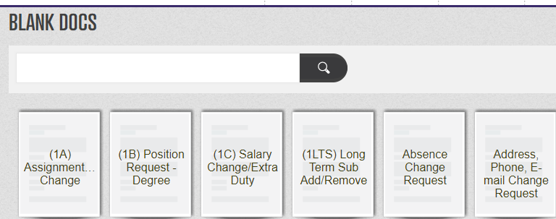
If you have multiple transactions to submit for a change, please include in one form. If you submit a new form and an existing form has not been completed, it will archive the original form before it can be processed.
To submit a form with multiple dates, select the earliest date you need to make a change to and include instructions in the comment box.
Your name and ID number will populate but you will need to select an alpha group. This will determine which payroll specialist will process your request. Select the category by you last name. 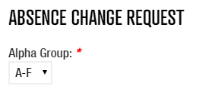
Select the date you need changed and the type of change requested. Don’t forget to leave instructions in the comments box if the type of request is not listed or needs clarification.
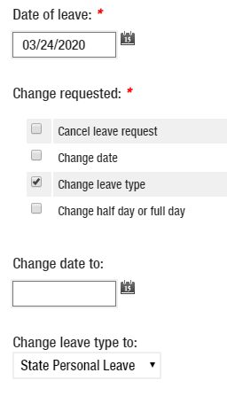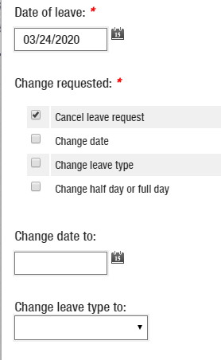
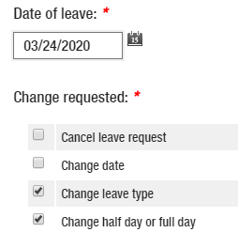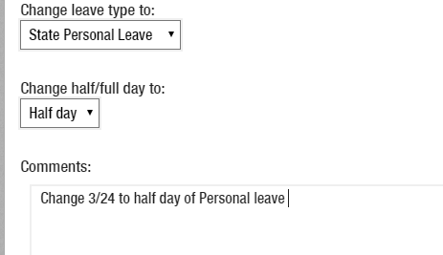

When you have completed the Absence Change Request form select “save final” at the bottom of the page to submit the form …

How does the form get processed?
The form will route to your Admin for approval. If the request is approved, it will then route to your payroll specialist to process.

This Photo by Unknown Author is licensed under CC BY-SA
Time off transactions in the system will be locked down when the payroll is run. If this is the case, you will see a negative transaction for the original entry and a positive transaction for the reversal. This is the offset and will update your leave balance.

If you have questions regarding your time off transactions, please email your payroll specialist.
Last name A - F: Kim Braun at kim.braun@boerneisd.net
Last name G - M: Ana Webb at ana.webb@boerneisd.net
Last name N - Z: Kathy Acosta at Kathy.Acosta@boerneisd.net

